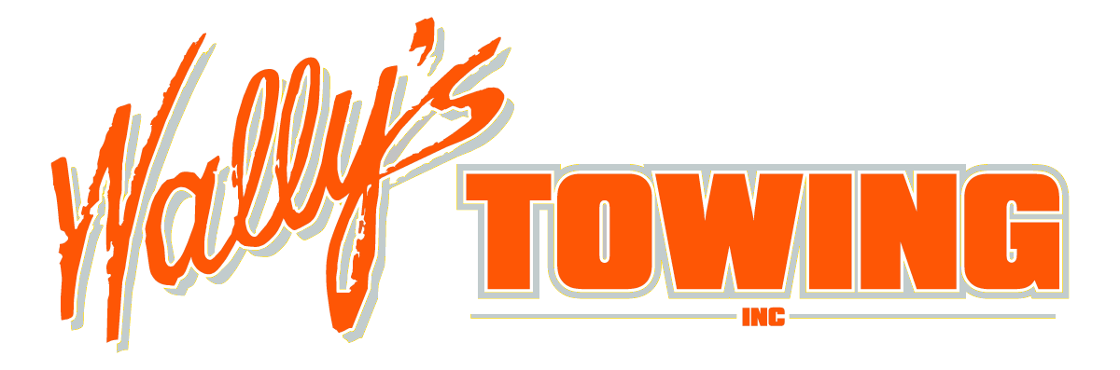

ADDRESS: 20510 60TH AVE WEST, LYNNWOOD WA 98036 PHONE: 425-672-0808 FAX: 425-712-0960

**NOTARIZED AUTHORIZATION TO RELEASE MOTOR VEHICLE FORM**

I, ____________________________ GRANT PERMISSION TO ___________________________

(NAME OF GRANTER) (NAME OF RECIPIENT)

TO VIEW, RELEASE PERSONAL BELONGINGS, AND/OR RETREIVE VEHICLE FROM IMPOUND OF MY

|  |  |  |  |  |
| --- | --- | --- | --- | --- |
| YEAR | MAKE | MODEL | COLOR | LICENSE # |
|  |  |  |  |  |

|  |
| --- |
| VEHICLE IDENTIFICATION NUMBER (VIN) |
|  |

X__________________________________ X__________________________________

(PRINT NAME OF PERSON GRANTING RELEASE) (SIGNATURE OF PERSON GRANTING RELEASE)

_________________________ ___________________ ______ ______________ ___________________

(STREET ADDRESS) (CITY) (STATE) (ZIP CODE) (PHONE NUMBER)

ON THIS ______DAY OF _______________ 20_______, ___________________________________ PERSONALY APPEAR

(NAME OF GRANTER)

BEFORE ME AND ACKNOWLEDGE THAT THE FORGOING AUTHORIZATION WAS APPROVED AND SIGNED BY HIM OR HER.

_________________________________________

NOTARY PUBLIC IN AND FOR THE COUNTY OF

____________________STATE ________________

MY COMMISION EXPIRES _____________________

PLEASE ATTATCH COPY OF GRANTERS PHOTO ID

THIS FORM WILL NOT BE ACCEPTED UNLESS IT IS ACKNOWLEDGED BY A NOTARY PUBLIC OR ATTORNEY AT LAW